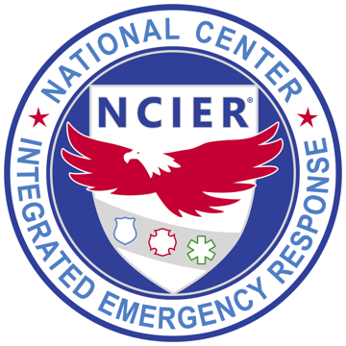
NATIONAL CENTER FOR INTEGRATED EMERGENCY RESPONSE®
Oviedo, Florida
FOR RELEASE: TUESDAY, SEPTEMBER 1, 2026, 12:26 P.M. ET
Media Contact: Marie Snively, Media Relations · NCIER / C3 Pathways, Inc. · (407) 490-1300 · marie.snively@c3pathways.com
NCIER® Releases Free Active Shooter Training for Every U.S. School and First Responder
School Safety and Violent Event Incident Management (SSAVEIM™) Foundations: 13 modules, under one hour, online, anytime. No cost, no prerequisites, no budget cycle.

OVIEDO, Fla. — September 1, 2026 — The National Center for Integrated Emergency Response (NCIER®) today released SSAVEIM Foundations. The course is free, online, and self-paced. It covers how a violent attack at a school unfolds and how a coordinated response works from the first 911 call to the moment the last student is returned to the right family.
SSAVEIM Foundations is available now at ncier.org/ssaveim/foundations.
Most school staff have practiced lockdown, but far fewer have been shown what happens next. SSAVEIM Foundations covers that gap: how responders work the incident, who commands when multiple agencies arrive, how a campus gets cleared, and how every student and staff member is accounted for by name.
The course runs 13 video modules, most 3-4 minutes long. School Staff and responders can complete it between classes or between calls. There are no prerequisites, every participant earns a certificate, and districts and agencies can track completion at no cost. Because it is free online and available 24/7, no community has to wait on a budget cycle or a training day to get everyone on the same page.
SSAVEIM Foundations is built to work alongside the protocols schools already use, including the Standard Response Protocol™ and Standard Reunification Method™ from The “I Love U Guys” Foundation. The course adds the shared picture of how the full response unfolds around those protocols and addresses both sides of the response. On the school side: teachers, front office staff, bus drivers, school resource officers, superintendents, and board members. On the responder side: law enforcement, fire, EMS, 911 dispatch, public information, and emergency management.
“Not having a plan and training on it costs lives when seconds count. We are dedicated to putting this proven, life-saving knowledge in the hands of as many school staff and emergency responders as possible, so the people who will be there on the worst day already know their part.”
— Bill Godfrey, CEO of C3 Pathways and its services division, NCIER
“It’s the conversation no one wants to have. Yet, it’s a conversation every school, district, or agency must have. Clear. Direct. To the point. These modules are spot on. The best part, they are accessible to educators and public safety professionals at no cost. Nailed it.”
— John-Michael Keyes, Strategic Initiatives Director and Founder, The “I Love U Guys” Foundation
SSAVEIM Foundations is the knowledge base beneath NCIER’s in-person SSAVEIM course with hands-on scenarios, delivered most recently to Orange County Public Schools and Central Florida responders ahead of the current school year.
About NCIER
The National Center for Integrated Emergency Response sets the national standard for integrated response to active shooter and hostile events. NCIER has delivered hands-on, scenario-driven training to law enforcement, fire, EMS, and other responders for more than 20 years. Programs include School Safety and Violent Event Incident Management (SSAVEIM), Active Shooter Incident Management (ASIM™), and the ASIM Checklist™. The National Tactical Officers Association (NTOA) endorses these programs. They comply with the National Incident Management System (NIMS). NCIER is the services division of C3 Pathways, Inc. Learn more at ncier.org.
Media kit: https://marketing.c3pathways.com/ssaveim-foundations-media-kit
# # #
NCIER® is the services division of C3 Pathways, Inc. · ASIM™, SSAVEIM™, Counterstrike® and ASIM Checklist™ are trademarks of C3 Pathways, Inc. · The “I Love U Guys” Foundation, Standard Response Protocol™ and Standard Reunification Method™ are trademarks of The “I Love U Guys” Foundation, used with permission under license.

